1.23 Response Assertion

This section will guide you to understand:

* How to add response assertion in JMeter

**Development Environment:**

Apache JMeter 5.1.1 Version

This guide has two subsections, namely:

1.23.1 Adding response assertion

1.23.2 Pushing the code to GitHub repositories

**Step 1.23.1:** Adding response assertion

Response assertion is used in test scripts to validate a pattern in the response body, header, code, message, etc. Steps to add response assertion in JMeter are shown below:

* Open the Apache JMeter.
* Click on the Test Plan.
* Rename the Test Plan.
* Right click on Test Plan --->Add--->Thread(users)--->Thread Group.

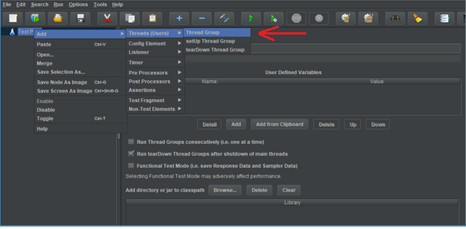

* Go to Thread Group--->Name--->Comments---> Continue --->Thread Properties--->Number of Threads(users): ---> Ramp-Up Period (in seconds): ---> Loop Count --->Save.

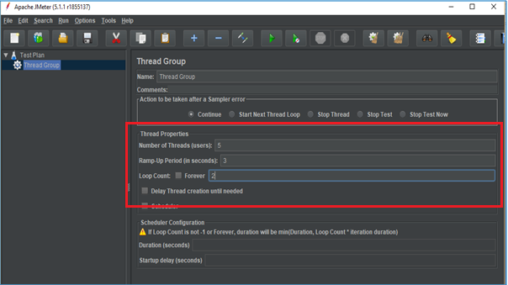

* Right click on Thread Group --->Add---> Sampler---> HTTP Request.

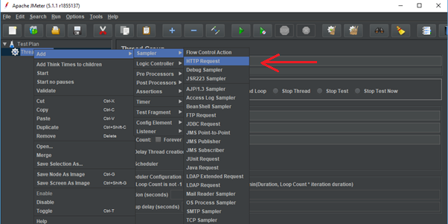

* HTTP Request---> Server Name or IP :---> Path :/---> Save.

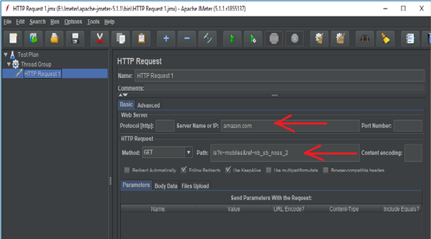

* Right click on Thread Group --->Add--->Listeners---> View Results Tree---> Run.

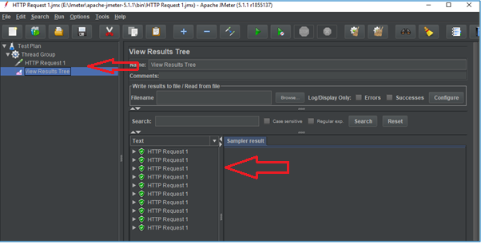

* Right click on Thread Group --->Add--->Listeners---> View Results in Table---> Clear All---> Save---> Run.

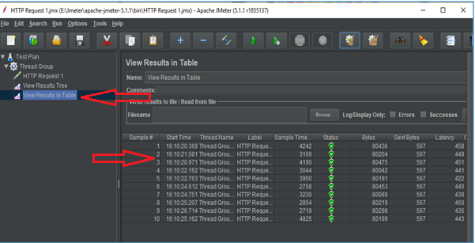

* Right click on Thread Group --->Add--->Listeners---> Assertions Results---> Clear All---> Save---> Run.

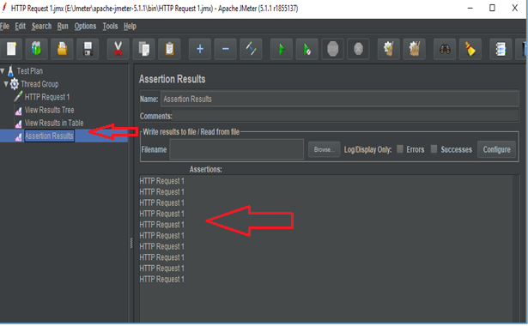

* Right click on Thread Group --->Add--->Assertions ---> Response Assertions---> Response Code---> Contains---> Add---> 201---> Save---> Clear All---> Run.

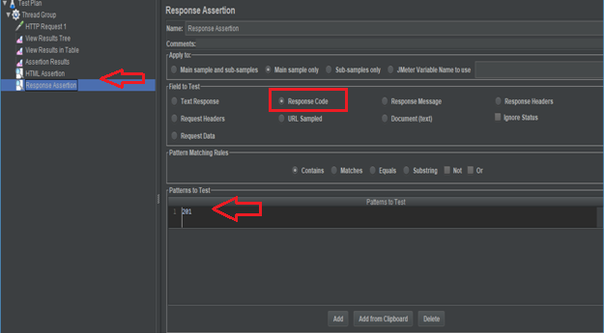

* Assertion Results---> Run. This will show an error.

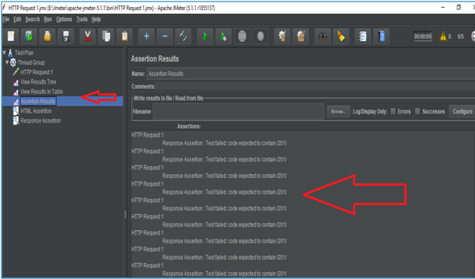

* Right click on Thread Group --->Add--->Assertions ---> Response Assertions---> Response Code---> Contains---> Add---> 200---> Save---> Clear All---> Run.

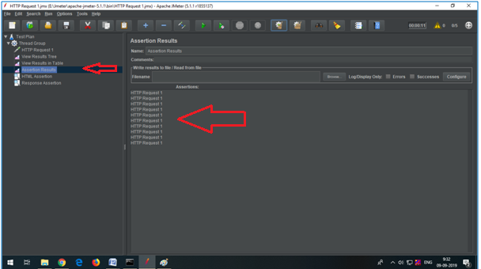

* Right click on Thread Group --->Add--->Assertions ---> Response Assertions---> Response Message---> Contains---> Add---> OK---> Save---> Clear All---> Run ---> View Results in Table.

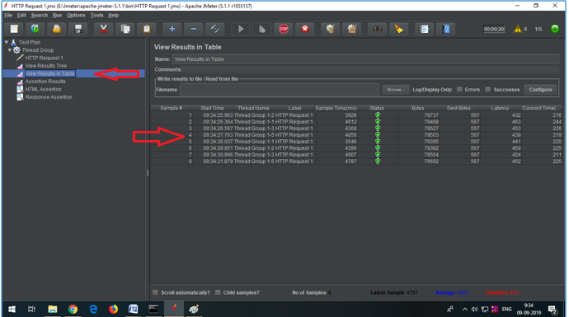

**Step 1.23.2**: Pushing the code to GitHub repositories

Open your command prompt and navigate to the folder where you have created your files.

cd <folder path>

Initialize your repository using the following command:

git init

Add all the files to your git repository using the following command:

git add . 

Commit the changes using the following command:

git commit . -m “Changes have been committed.”

Push the files to the folder you initially created using the following command:

git push -u origin master